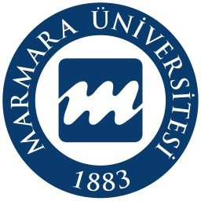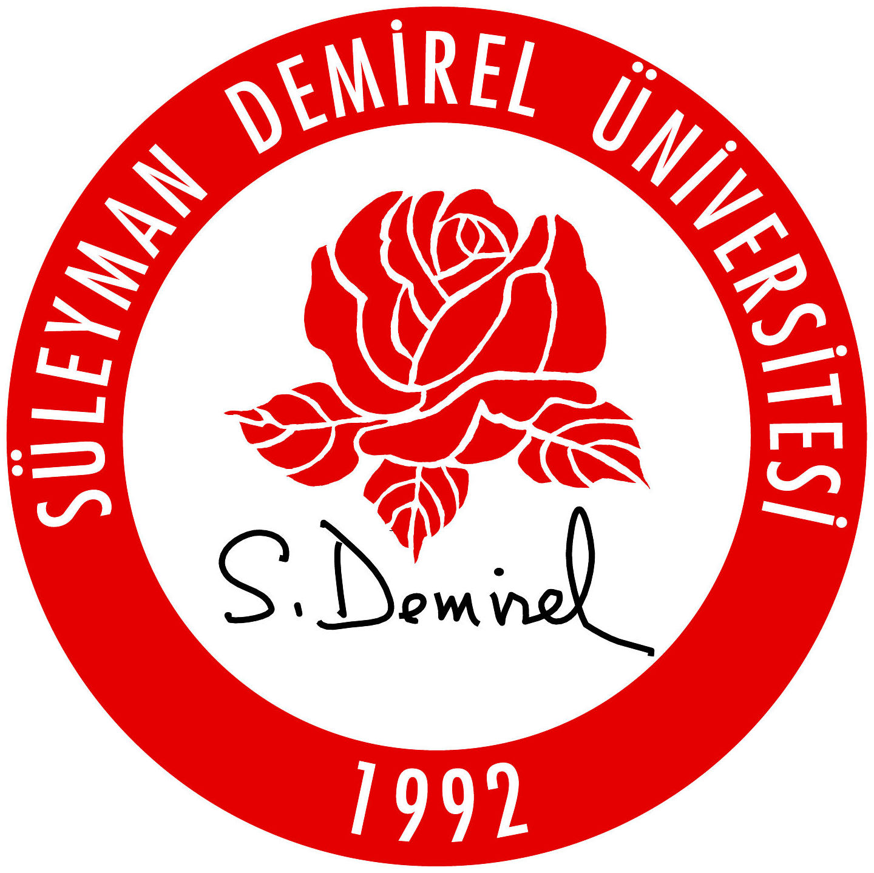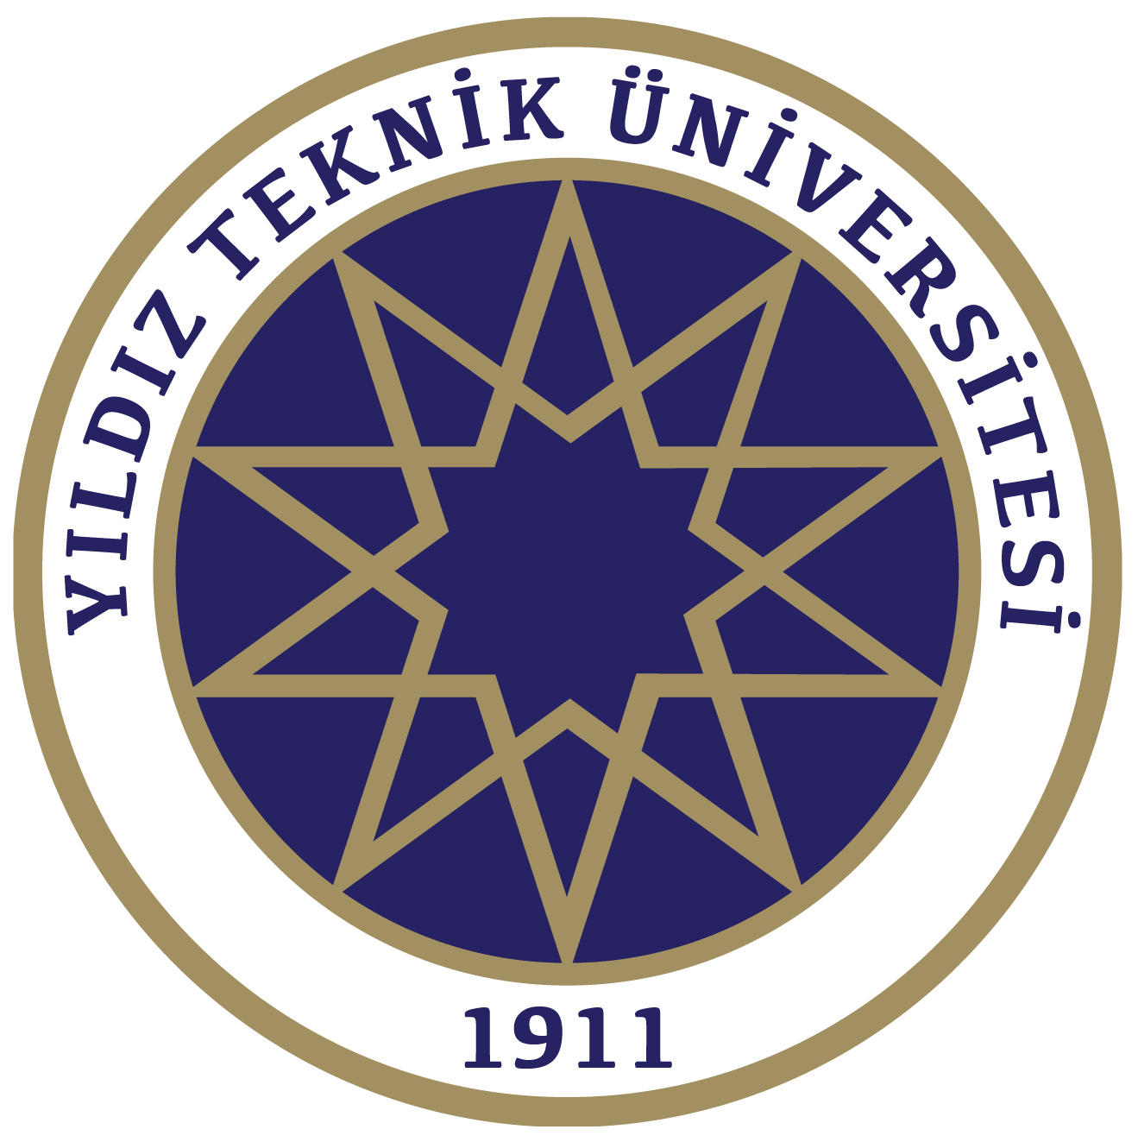
24 KASIM ÖĞRETMENLER GÜNÜ
ULUSLARARASI JÜRİLİ ÇEVRİMİÇİ KARMA SERGİ
24 KASIM – 25 ARALIK 2025
24 NOVEMBER TEACHER’S DAY
INTERNATIONAL JURIED ONLINE MIXED EXHIBITION
24 NOVEMBER – 25 DECEMBER 2025

Sergi Başvuru Formu / Exhibition Application Form

Sanatçı Fotoğrafı
Artist Photo

AD SOYAD / NAME SURNAME
(BÜYÜK HARFLE YAZINIZ / WRITE IN CAPITAL LETTERS)
Akdemik Ünvan / Academic Title
Çalıştığınız Kurum /
The Institution Your Work
Kısa Özgeçmiş / CV (En Fazla 200 Kelime)
Short CV (Maximum 200 Words)
Adres / Address
E–posta / E–mail
Telefon / Telephone
Eserin Boyutu / Dimensions of the Artwork
Materyal / Material
Teknik / Technical
Yapım Yılı / Year of Construction

Son Başvuru Tarihi: 15 Kasım 2025 / Application Deadline: 15 November 2025

Eser Görseli / Artwork Image

Eserinizi tablonun içine yerleştiriniz
Place your work inside the painting

EXHIBITION PARTICIPATION CONDITIONS
1. Participation in the exhibition is free of charge.
2. Graduates with a bachelor’s degree, students currently in their postgraduate studies and academics in various disciplines of art are invited to participate in the exhibition.
3. Each participant can participate with 1 (one) work from 2023 and later that has not been exhibited before. Subject, technique and work size are free.
4. Works deemed appropriate by the Exhibition Organizing Committee will be exhibited.
5. Exhibition Application Deadline: 15 November 2025. Exhibition applications will be made via the https://gestuam.marmara.edu.tr/en/event/24-november-teachers-day-international-online-group-exhibition-24-november-25-december-2025 link and the participant name will be written in CAPITAL LETTERS in the application system. The APPLICATION FORM in word format downloaded from the exhibition application page will be filled out and uploaded to the application link. In order to avoid confusion in the artwork images, the artwork image must be added to the second page of the application form. If the Word page is incomplete or not filled as requested, the application will not be accepted.
6. The artwork image will be uploaded to the exhibition application link in high resolution JPEG (JPG) format (Max. 10 Mb). If the Word page is incomplete or not filled in as requested, the application will not be accepted. Since the exhibition is online, the work visual must be suitable for display. The detail visual of the work cannot be accepted as the work itself. The work image must be recorded as the Participant name, Work name, Technique, Dimensions, Year and uploaded to the application system. Applications made with images that do not include the participant name in the work image and are not exhibitable will not be accepted.
7. The works will be exhibited at the exhibition link at https://gestuam.marmara.edu.tr/en
8. When the exhibition participation documents are prepared, they will be available as a pdf file in the exhibition link at https://gestuam.marmara.edu.tr/en.
9. Participants; official website of his works, social media, e-catalogue, posters, etc. They are deemed to have given permission to be published in media such as.

IMPORTANT DATES
Application Deadline: 15 November 2025
Exhibition Calendar: 24 November – 25 December 2025

Exhibition Announcement Addresses:
https://gestuam.marmara.edu.tr/en

