|  |
| --- |
|  |

|  |
| --- |
|  |

**15 TEMMUZ DEMOKRASİ VE MİLLİ BİRLİK GÜNÜ ULUSLARARASI JÜRİLİ ÇEVRİMİÇİ KARMA SERGİ,**

**15 – 30 TEMMUZ 2025**

**JULY 15 DEMOCRACY AND NATIONAL UNITY DAY INTERNATIONAL JURIED ONLINE MIXED EXHIBITION,**

**15 – 30 JULY 2025**

**Sergi Başvuru Formu / Exhibition Application Form**

Sanatçı Fotoğrafı

Artist Photo

|  |  |
| --- | --- |
| AD SOYAD / NAME SURNAME  **(BÜYÜK HARFLE YAZINIZ / WRITE IN CAPITAL LETTERS)** |  |
| Akdemik Ünvan / Academic Title |  |
| Çalıştığınız Kurum /  The Institution Your Work |  |
| Kısa Özgeçmiş / CV (En Fazla 200 Kelime)  Short CV (Maximum 200 Words) |  |
| Adres / Address |  |
| E–posta / E–mail |  |
| Telefon / Telephone |  |
| Eserin Adı / Name of the Work |  |
| Eserin Boyutu / Dimensions of the Artwork |  |
| Materyal / Material |  |
| Teknik / Technical |  |
| Yapım Yılı / Year of Construction |  |

**Son Başvuru Tarihi: 01 Temmuz 2024 / Application Deadline: 01 July 2024  
Form Gönderimi / Form Submission:** [**gestuam@gmail.com**](mailto:gestuam@gmail.com)

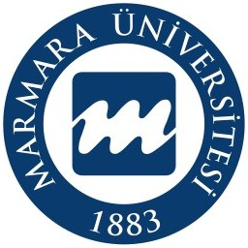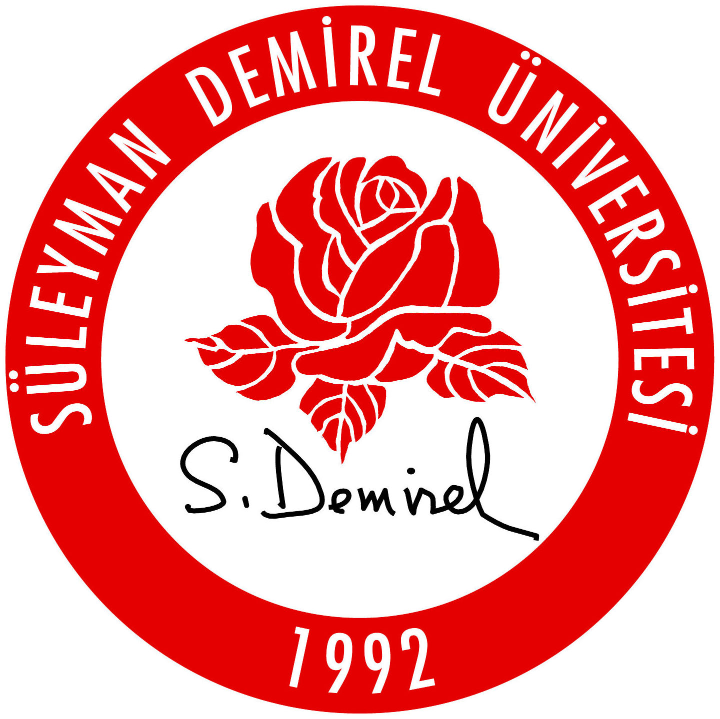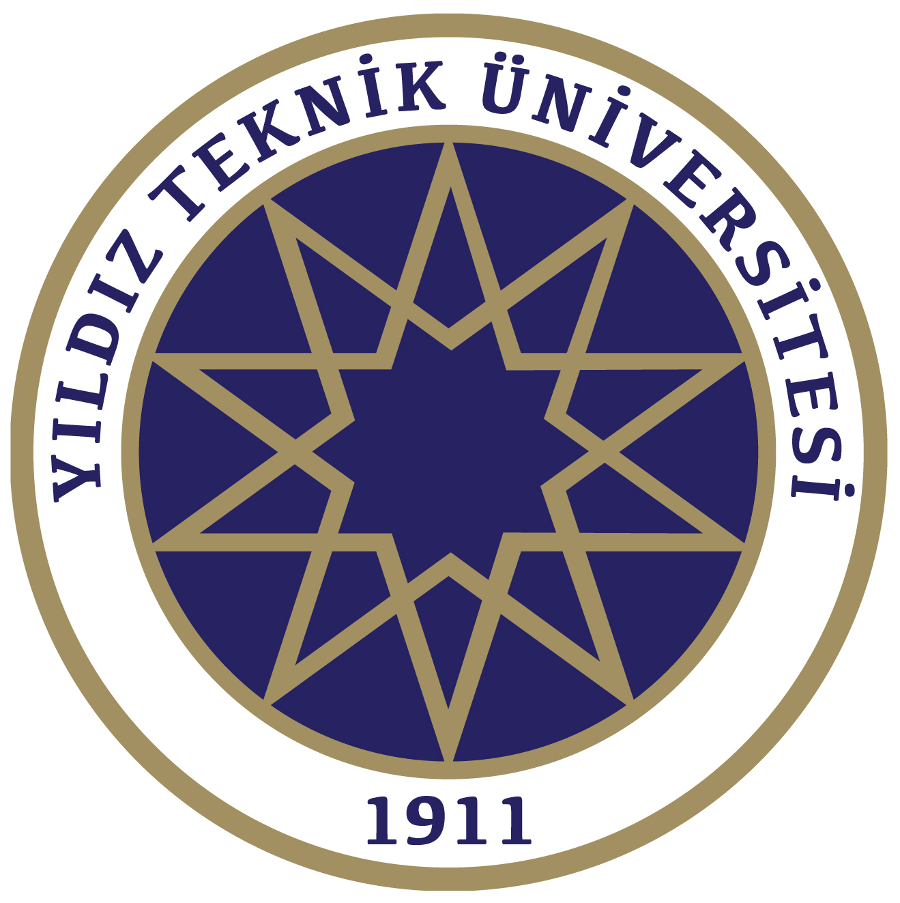

**Eser Görseli / Artwork Image**

**Eserinizi tablonun içine yerleştiriniz**

**Place your work inside the painting**

|  |
| --- |
|  |



**EXHIBITION PARTICIPATION CONDITIONS**

**1.** Participation in the exhibition is free of charge.

**2.** Graduates with a bachelor’s degree, students currently in their postgraduate studies and academics in various disciplines of art are invited to participate in the exhibition.

**3.** Each participant **can participate with 1 (one) work from 2023 and later that has not been exhibited before**. Subject, technique and work size are free.

**4.** Works deemed appropriate by the Exhibition Organizing Committee will be exhibited.

**5.** Exhibition Application Deadline: **05 July 2025**. Exhibition applications will be made via the <https://gestuam.marmara.edu.tr/en/event/july-15-democracy-and-national-unity-day-international-juried-online-mixed-exhibition-15-30-july-2025> link and the participant name will be written in **CAPITAL LETTERS** in the application system. The **APPLICATION FORM** in word format downloaded from the exhibition application page will be filled out and uploaded to the application link. In order to avoid confusion in the artwork images, the artwork image must be added to the second page of the application form. If the Word page is incomplete or not filled as requested, the application will not be accepted.

**6.** The artwork image will be uploaded to the exhibition application link in high resolution JPEG (JPG) format. If the Word page is incomplete or not filled in as requested, the application will not be accepted. Since the exhibition is online, the work visual must be suitable for display. The detail visual of the work cannot be accepted as the work itself. **The work image must be recorded as the** Participant name, Work name, Technique, Dimensions, Year and uploaded to the application system. Applications made with images that do not include the participant name in the work image and are not exhibitable will not be accepted.

**7.** The works will be exhibited at the exhibition link at **https://gestuam.marmara.edu.tr/en**

**8.** When the exhibition participation documents are prepared, they will be available as a pdf file in the exhibition link at **https://gestuam.marmara.edu.tr/en**.

**9.** Participants; official website of his works, social media, e-catalogue, posters, etc. They are deemed to have given permission to be published in media such as.

**IMPORTANT DATES**

Application Deadline: 05 Jul 2025

Exhibition Calendar: 15 – 30 July 2025

**Exhibition Announcement Addresses:**

<https://gestuam.marmara.edu.tr/en>